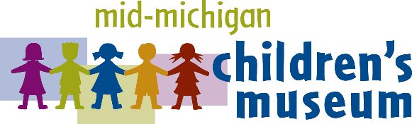
MEDIA RELEASE

CONTACT: Emily Yeager, President & CEO or Alisha Toyzan, Marketing Coordinator
315 W. Genesee Ave.
Saginaw, MI 48602
(989) 399-6626
eyeager@michildrensmuseum.com

Mid-Michigan Children’s Museum Announces
The Tinkery™ Gift Gallery grand opening

SAGINAW, MI – Oct. 2, 2017: The Mid-Michigan Children’s Museum will host a grand opening event for The Tinkery™ - The Mid-Michigan Children’s Museum Gift Gallery on Tuesday, October 10 from 4 p.m. to 6 p.m. The event will feature a ribbon cutting at 4 p.m., refreshments, prize drawings and a chance to visit the new toy and gift shop.

“The Tinkery project has been a long time in the making,” explained Emily Yeager president and CEO of the museum. “Our guests have remarked that our previous gift shop was in desperate need of an overhaul and we wholeheartedly agreed, but we wanted to make sure that we hit this one out of the park.”

Beginning with industry expertise from Michael Keller Zehnder, General Manager/Owner of the Bavarian Inn Lodge, and Reid Sanders, Corporate Buyer and Inventory Manager of Frankenmuth Gift Shops, Inc, the Mid-Michigan Children’s Museum began developing a specialty toy store and gift shop.

The previous gift shop closed down in mid-July and work began in the 300 sq. ft. area that was formerly used as a lunchroom. Through retail expert mentoring and museum member input, the staff determined that a shop where guests could purchase high-quality, educational toys that align with the museum’s 10 hands-on galleries would be an ideal fit.

“Alisha Toyzan, our marketing coordinator, really ran with this project! She did all the research, went to Philadelphia to attend the American Specialty Toy Retailing Association’s Certified Play Expert training to become an expert on toys and play, and then developed the design and inventory plan.” Yeager said. “But even with all that she has done, we couldn’t have put this fantastic shop together without additional help from Bavarian Inn Lodge management, Saginaw-Shiawassee Habitat for Humanity volunteers and the custom-machined car parts from the UAW Local 668 that decorate the new shop.”

A sign on the door of The Tinkery states, “All sales support your Mid-Michigan Children’s Museum and make our galleries, exhibits, and programs possible. Your purchase helps kids play and learn, so go ahead and grab another toy. We couldn’t do what we do without YOU!” Yeager was quick to point out that unlike for-profit big box stores, all sales at The Tinkery support the museum’s mission to provide a fun, hands-on environment where children use their curiosity and creativity to learn about their world.

The Mid-Michigan Children’s Museum is the only hands-on museum in our Great Lakes Bay Region designed especially for children ages newborn through 10 years old. Each gallery was designed by children’s museum specialists and educators to ensure that children are educationally engaged as they play.

To learn more about the event, please call (989) 399-6626.

# # #

About the Mid-Michigan Children’s Museum
The Mid-Michigan Children’s Museum is a local 501(c)(3) nonprofit organization dedicated to providing a fun, hands-on environment where children use their curiosity and creativity to learn about their world. For more information, call (989) 399-6626 or visit michildrensmuseum.com.

